Microsoft SQL Server. Lab #3. Data Sampling
Target:teach how to use the SELECT statement and its main sections to select data according to specified conditions.
Theoretical material: Before performing the lab work, it is recommended to study Lecture No. 4 “Data Selection”, which studies one of the main SQL language operators – SELECT and explains the purpose of each of its sections.
Reporting requirements: based on the results of the work, present a set of SQL scripts that solve the problems from the “Independent Work” section.
Task 1. Connect to the MyServ server using the Management Studio utility.
Instructions for implementation:
- Launch SQL Server Management Studio from the Start menu – Programs – Microsoft SQL Server 2008.
- Select authentication type: SQL Server Authentication. Specify User name: sa, and Password: empty and click Connect.

Task 2. Get a list of countries with their code and the last date of record modification from the CountryRegion table of the AdventureWorks2008 database.
Directions for implementation:
- To complete the task we will need attributesCountryRegionCode, [Name],ModifiedDatefrom the tablePerson.CountryRegion. Note that the table name is preceded by the Person schema name, which is used to manage objects related to employees and departments.
- To rename columns, we will use the keywordAS.
- Make sure, what BDAdventureWorks2008is current, and execute the following query: SELECT CountryRegionCode AS 'Code', [Name] AS 'Country',
ModifiedDate AS 'Modified Date'FROM Person.CountryRegion
The result of executing the query is shown in Fig. 3.1.
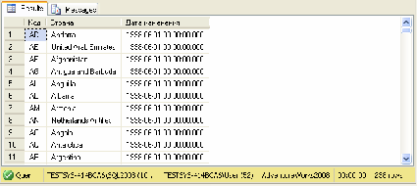
Fig. 3.1. List of countries

Task 3. Get a list of employees with their last name and first character of their first name, as well as their identification number. The list should be sorted by the employee's last name and first name.
Directions for implementation:
- We will have to rename the first column using the operatorAS, since it requires combining data from two columns:LastNameAndFirstName.
- To get only the first letter of the name, we will use the Substring function.
- To sort the resulting table, you need to use the sectionORDER BY.
- Run the following code:
SELECT LastName+' '+Substring(FirstName,1,1)+'.' as [Employee Name], BusinessEntityID FROM Person.Person
ORDER BY [Employee name]
The result of executing the query is shown in Fig. 3.2.
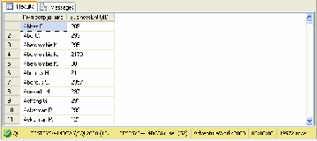
Fig. 3.2. List of employees
Comment.By default, sorting is performed in ascending order, which corresponds to the reserved word ASC (may not be specified); for sorting in descending order, DESC is specified.

Task 4. Get a list of products whose price is in the range from $12 to
$20, sorted by price.
Directions for implementation:
- To select records according to a given criterion, you must use the section
WHERE.
- You can use a compound condition, then the code will look like this: SELECT [Name], ListPrice From Production.Product
WHERE (ListPrice>=12) and (ListPrice<=20)

ORDER BY 2
- Another option: replace the two comparison operators with one logical operatorBETWEEN, with the help of which you can get an answer to the question of whether the value lies in the specified range:
SELECT [Name], ListPrice From Production.Product WHERE ListPrice Between 12 and 20
ORDER BY ListPrice
The result of executing the query is shown in Fig. 3.3.
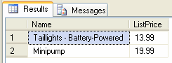
Fig. 3.3. List of products with price from $12 to $20

USA.
Task 5. Display the names of employees and their positions living outside
Directions for implementation:

- To search for a pattern of character strings, a logical operator is used.LIKE, which is most often used in situations where an exact match is not known.
- In the template we will need to specify a service character%, which means any string consisting of 0 or more characters.
- Using tableHuman Resources.vEmployeeLet's create a query: Select LastName, JobTitle From HumanResources.vEmployee Where CountryRegionName Not Like '%United States%' The result of executing the query is shown in Fig. 3.4.
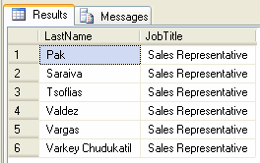
Fig. 3.4. Employees residing outside the United States

Task 6. Get a list of employees from the USA and Canada.
Directions for implementation:
- To determine whether an expression matches one of the values ​​listed in a given list, a logical operator is used.IN. This operator can always be written as a group of conditions united by an operandOR.
- Request using the operatorINwill look like this: Select LastName, JobTitle From HumanResources.vEmployee
WHERE CountryRegionName IN ('United States', 'Canada') The result of the query is shown in Fig. 3.5.
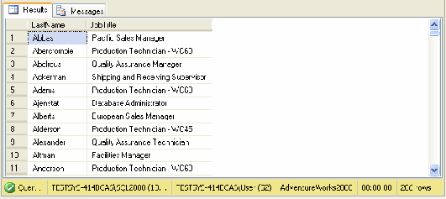
Fig. 3.5. Employees from the USA and Canada

Task 7. Get a list of products that do not have a color specified.
Directions for implementation:
- To check for the absence of a value, the IS NULL sampling function is used.
- Let's make it up next query on tableProduct: SELECT [Name] FROM Production.Product WHERE Color IS NULL
The result of executing the query is shown in Fig. 3.6.
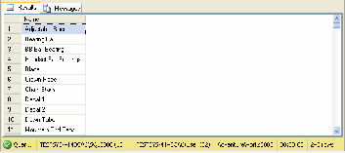
Fig. 3.6. Products for which color is not specified

Independent work
- Display information about the delivery methods of the product (ShipMethod), if the active user has the right to receive this data.
- Construct a query that returns a list of employees (tableEmployee) indicating themEmployeeID, date of birth (in dd.mm.yyyy format) and age as of today.
- Hint: To convert a value of one type to a value of another type, use the function:CONVERT(type, expression[, style]).
- Identify the list of products that have been discontinued (usingSellEndDate), indicating their color.
- Get warehouse locations fromProduction.Location,containing 'Paint' in their name.
- Display a list of countries where customers are registered. The selection should be made from the viewvIndividualCustomer, and not from the table, because the table does not contain enough information for such a request.

